

Project Interim Report

On

Expense Tracker Application (Using Core Java & OOP Concepts)
RU-100-01-00012
Object-Oriented Programming with Java

SESSION: 2025-26

Submitted By
Rooshal Kamble
ERP - 11209

Bachelor of Technology in Computer Science
& Engineering (AI) in association with Google

Under the Guidance of Mr. Ashish Shivhare IB

SCHOOL OF COMPUTER SCIENCE AND ENGINEERING RUNGTA INTERNATIONAL SKILLS UNIVERSITY
BHILAI, CG

(April 2026)

Abstract

The Expense Tracker Application is designed to provide an easy-to-use interface for recording, tracking, and analysing users’ everyday expenditures in an organised way. In our fast-paced society, we often lose track of how much money we are actually spending, leading to poor financial planning and additional costs. This application will promote improved financial awareness and assist users with managing their budgets.

Using the Expense Tracker App, users can quickly add, edit, and delete expense records. Each expense will also have a name or description, a category (i.e. , Food, Travel, Entertainment), and the amount spent for each expense. The application will also allow users to view all previous expenses, calculate their total amount spent, and create summaries of expenditures by category. By having access to all of this information, users can more easily understand how much they are spending in total, as well as in each category, and will be able to determine where they can cut back on expenses.

The application was developed using Object-Oriented Programming principles which will allow for efficient organisation and scalability. Overall, the Expense Tracker Application is intended to be a practical financial management tool that will help users keep track of how they spend their money and help them make smarter financial decisions.

Introduction

The Expense Tracker is a simple, intuitive program that helps people track and manage all of the purchases they make every day. Tracking personal expenses can be a challenge; therefore, tracking expenses can lead to overspending and bad budgeting habits. With a structured method of organizing expenses, people can become more aware of their financial situation and take control of it.

The goal of the Expense Tracker application is to allow users to easily record, maintain, and track the costs of their daily expenses. Users can document every expense they have incurred with relevant information, such as what the expense was for (name or description), where the expense was incurred (category, e.g., food, travel, entertainment, utilities), the total dollar amount spent on an expense, and the date the expense was incurred. The expense tracker will tally the total amount of money spent during an identified timeframe. The Expense Tracker will provide the user with a true picture of how much money they have spent. The application will also generate summaries of all expenses based on categories, which help users see how their money is being allocated.

The Expense Tracker has a user-friendly interface, allows users to track expenses in real time, generates summary reports and provides analytical tools to help users better understand how they were spending their money. The Expense Tracker encourages users to budget effectively and make educated financial decisions.

Scope
This project is suitable for small libraries and can be extended with database integration in future.

System Requirements
Hardware: Computer with 4GB RAM
Software: Java JDK, IDE (VS Code/Eclipse/Edit Plus)

Methodology

• The user begins by entering expense details such as the expense name or description, category (e.g., Food, Travel, Entertainment), and the amount spent.

• Each expense is assigned a unique expense ID and stored as an object in a data structure like an ArrayList using object-oriented programming principles.

• The system allows users to view all recorded expenses in a structured and organised format for easy tracking.

• Users can search for specific expenses using the expense ID or category to quickly access required records.

• Existing expense entries can be modified by locating the expense through its ID and updating the necessary details.

• Users can delete unwanted or incorrect expenses, and the system removes the corresponding record from storage.

• The application automatically calculates the total spending by summing the amounts of all stored expenses.

• Expenses are grouped by their respective categories, and the system generates category-wise summaries to help users understand spending distribution.

• Input validation ensures that the expense amount is positive and that mandatory fields such as the category are not left empty.

• The system helps users analyze their spending habits, enabling better budgeting and informed financial decision-making.

• Optional enhancements may include monthly expense tracking, budget limit alerts, file-based data storage, graphical visualizations, and a graphical user interface for improved usability

Flowchart

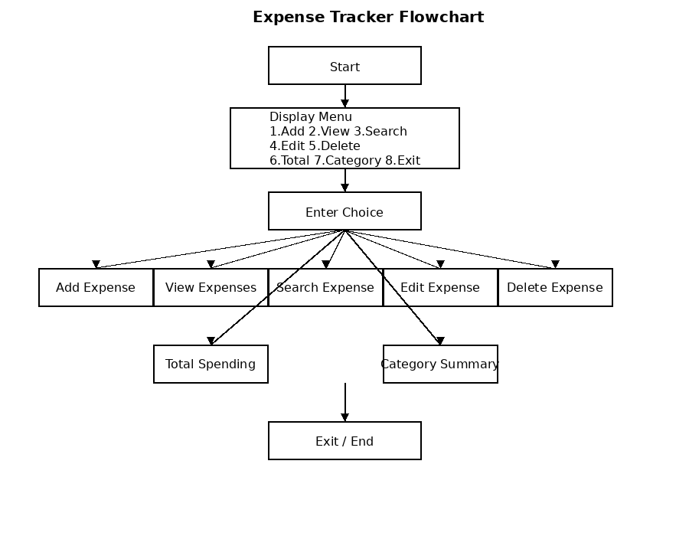
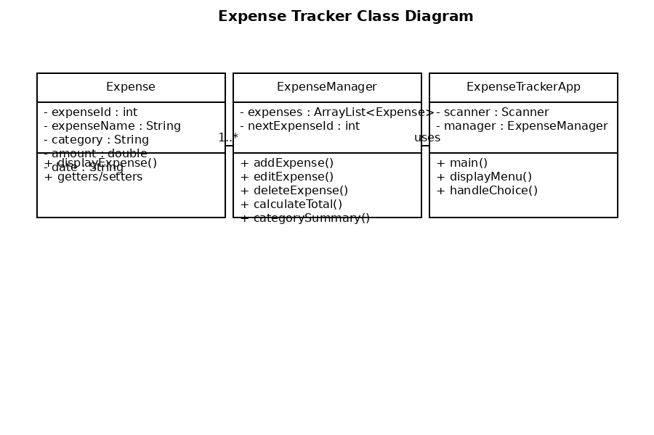

Implementation
• Expense Class
- Represents a single expense entry.
- Stores details such as expenseId, expenseName, category, amount, and optionally date.
- Provides methods to access, update, and display expense information.
- Acts as the fundamental data model of the application.

• ExpenseManager Class
- Manages all business logic of the system.
- Maintains an ArrayList of Expense objects to store multiple records.
- Generates category-wise summaries to analyse spending patterns.
- Ensures each expense has a unique ID.

• ExpenseTrackerApp (Main Class)
- Serves as the entry point of the program.
- Provides a menu-driven interface for user interaction.
- Accepts user input and invokes appropriate methods from ExpenseManager.
- Controls the program flow until the user chooses to exit.

• Sample Input/Output
- Menu options include: Add Expense, View Expenses, Search, Edit, Delete, Total Spending, Category-wise Summary, and Exit.
- Example Output:
  - ID: 1 | Name: Lunch | Category: Food | Amount: ₹200
  - Total Spending: ₹200
  - Category-wise Summary: Food: ₹200
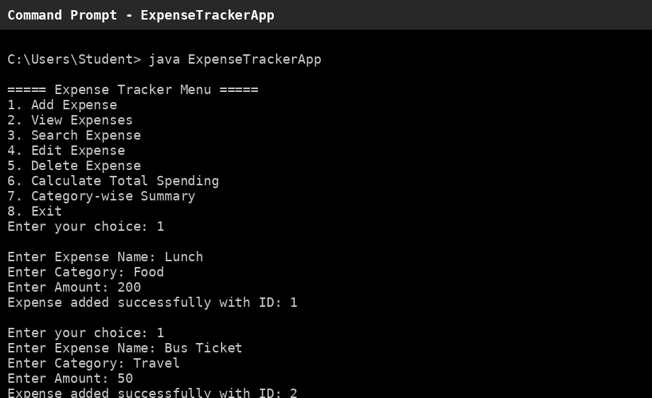

• Terminal Screenshot
- Capture the terminal showing different operations such as adding, editing, deleting, and viewing summaries.
- Use tools like Win + Shift + S (Windows), PrtSc (Linux), or Cmd + Shift + 4 (macOS).
- Suggested caption: “Terminal Output of Expense Tracker Application.”

• Future Enhancements
- Add a graphical user interface (GUI) using Java Swing or JavaFX.
- Implement persistent storage using files or databases (MySQL/SQLite).
- Introduce user authentication for multiple users.

Gantt Chart
Task | Week 1 | Week 2 | Week 3 | Week 4 | Week 5 | Week 6 | Week 7 | Week 8
Requirement Analysis | ██████
System Design |  | ██████
Coding |  |  | ██████ | ██████ | ██████
Testing |  |  |  |  |  | ██████
Documentation |  |  |  |  |  |  | ██████
Deployment |  |  |  |  |  |  |  | ██████

Conclusion
The project successfully demonstrates Java OOP concepts and provides a functional system.

References Book
1.H. Schildt, *Java: The Complete Reference*, 11th ed. New York: McGraw-Hill, 2018.

2. K. Sierra and B. Bates, *Head First Java*, 2nd ed. Sebastopol, CA: O’Reilly Media, 2005.

Website
Oracle, "Java Documentation," Oracle. [Online]. Available: https://docs.oracle.com. [Accessed: Apr. 14, 2026].

Oracle, "JDBC Basics," Oracle. [Online]. Available: https://docs.oracle.com/javase/tutorial/jdbc. [Accessed: Apr. 14, 2026].

Journal Article :
A. Sharma and R. Gupta, "Personal Finance Management Using Software Applications," International Journal of Computer Applications, vol. 182, no. 10, pp. 15–20, 2018.

S. Patel and M. Desai, "Design and Development of a Financial Management System," International Journal of Advanced Research in Computer Science, vol. 9, no. 3, pp. 245–250, 2018.

